Notes 20-03

* Everyone: look at report + add comments
* Lotte: fusion of images and dice score
* Christos, Noortje & Funmilayo: look at code of VAE and look at improvements
* Milan: look at SPADE
* Raquel: finish report part of equation

Lotte, Funmilayo, Christos, Milan & Noortje: look at report

# Fusion of images

Staple works for 3D images

Dice doesn’t work for 3D. Also Lotte thinks that looping over slices to calculate dice is not very stable, different results appear whenever you loop over x, y, z.

Lotte found a 3D dice calculation, however the scores are very low. This might be due to the slices at the side of the segmentation. This should be mentioned in the report (discuss how to explain this).

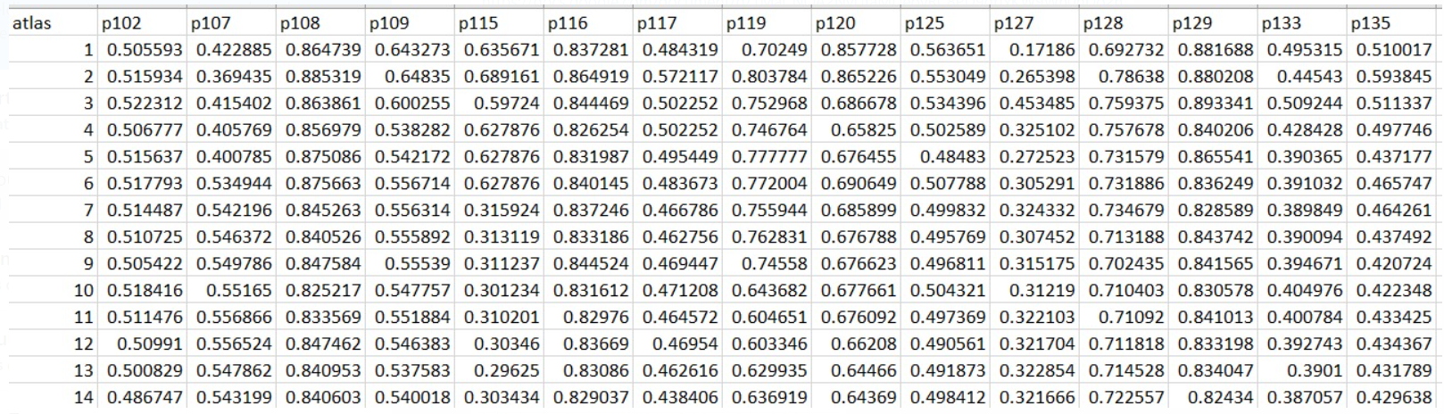

All images have a bad MI (0.046… is highest), this is generated after the affine registration.

Some patients don’t have a match in the dataset (the highest MI image is not resulting in a good registration). As you can see, the dice score doesn’t improve much when you use more atlases.

* We can try to generate the same results by picking randomly images that are used in the registration?
  + We will try this, discuss difference between MI and random selection. Then we conclude this part (this might be a reason why you would use a U-net instead)
* We can look at a different metric (instead of MI): mean squared error. This might give a more clear preference.

Discussion: if we would have a bigger dataset there would be more MI images.

# VAE

Funmilayo: tried to understand everything, but didn’t had time to improve.

Noortje & Christos looked at the VAE, both are stuck at generating of images.

# SPADE

Couldn’t find the code on Github. We will discuss this next time.

# Questions to Cian:

* STAPLE: loop over every 2D slice and then determine?
* Can we use a GridSearchCV to optimize the hyper-parameters of the U-net?
* How to input the data into the model while using GridSearchCV
* Are the inputs correct
* How should we predict it

# Project idea / concept

Generate images with VAE. Either generate labels by:

* Registration segmentation method
* Conditional GAN: we can insert the wished label. This label can be created by affine transformations on labels of the dataset that we have.
* SPADE: helps to generate images based on a label?

With those images, we can better train the U-net (as we have more data) and we will optimize the U-net with the GridSearchCV.

Evaluate performance of U-net with and without generated labels?

# Next meeting (Thursday 14:00?)

* Lotte, Funmilayo, Christos, Milan & Noortje: look at report
* Lotte: generate random results of the registration
* Funmilayo: Write results of registration
* Raquel & Christos: Figure out how to apply a grid search on a machine learning part, if it doesn’t work than try to manually implement it
* Milan: Look into more detail to spade
* Noortje: during training VAE, think about disadvantages (for discussion) and see you we can overcome those disadvantages or not.
* *Look into how to get more variating images*
  + *Include contrast style variation (lecture 3)*
  + *Label deformation to provide anatomical variation (lecture 3)*

If the SPADE doesn’t work out, we can deform labels and use a conditional GAN.

Wait with writing the machine learning part, until we have a clear view

# Questions to Cian:

* Can we use a GridSearchCV to optimize the hyper-parameters of the U-net?

Sklearn GridsearchCV assumes that a sklearn model is used. Look into PyTorch grid search.

* How to input the data into the model while using GridSearchCV

Conclusion: VAE works!

SPADE: replaces the batch normalization layers. Compute the gamma and beta from the inserted label

Also an option to segment the images with another u-net

## Visit tensor board

activate your_environment_name

tensorboard --logdir=vae_runs